**1,The implementation of Level 0 and Level 1 DFD is implemented in Fig.1 and Fig. 2 respectively for a Patient Support System.**

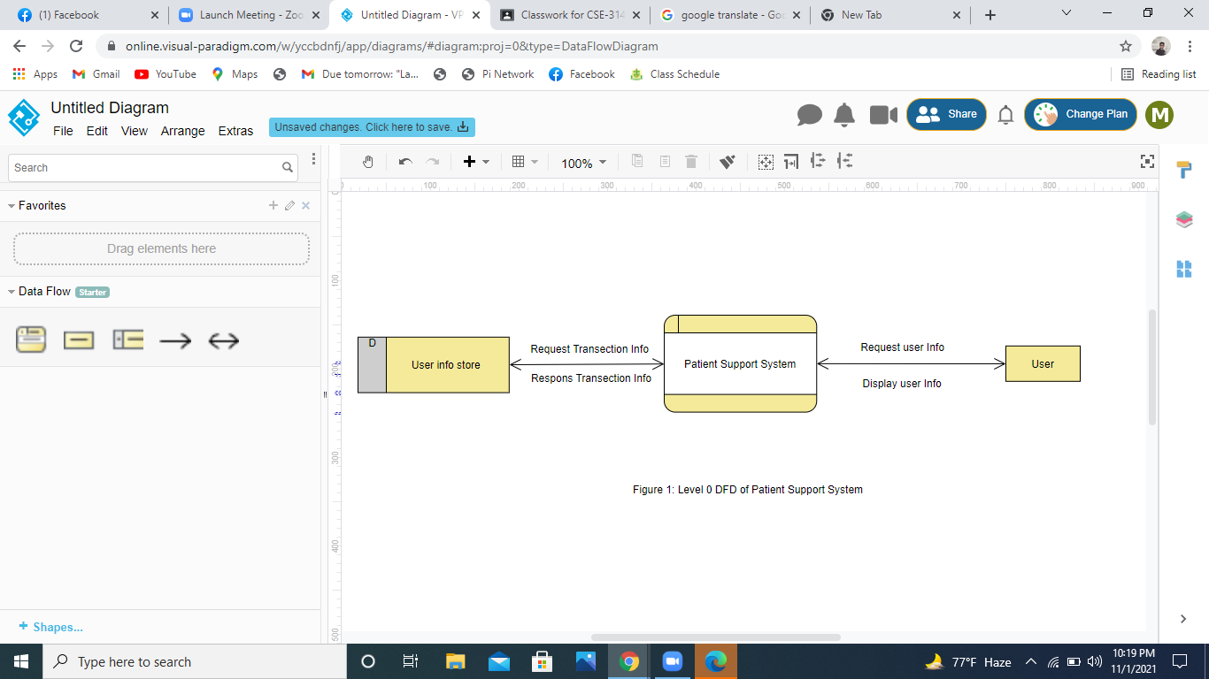

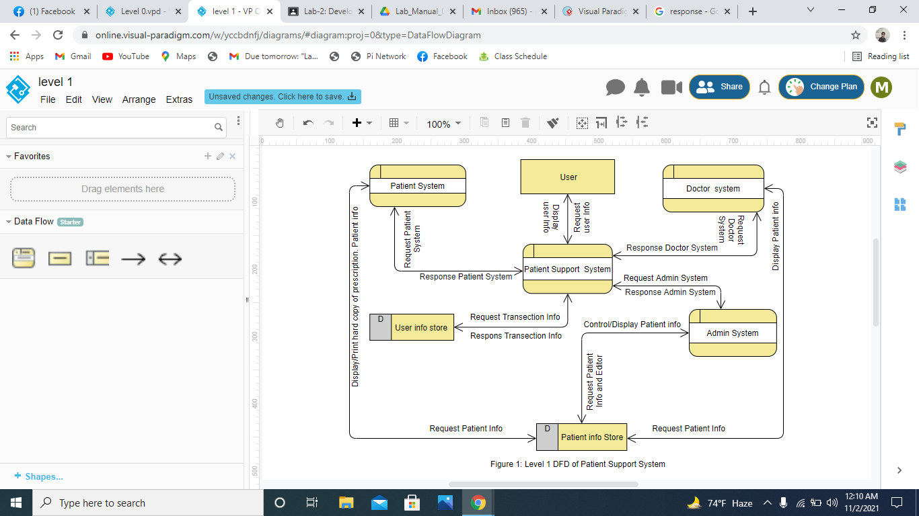

**2.The use case diagram of Patient Support and Service System is shown in Fig.3.**

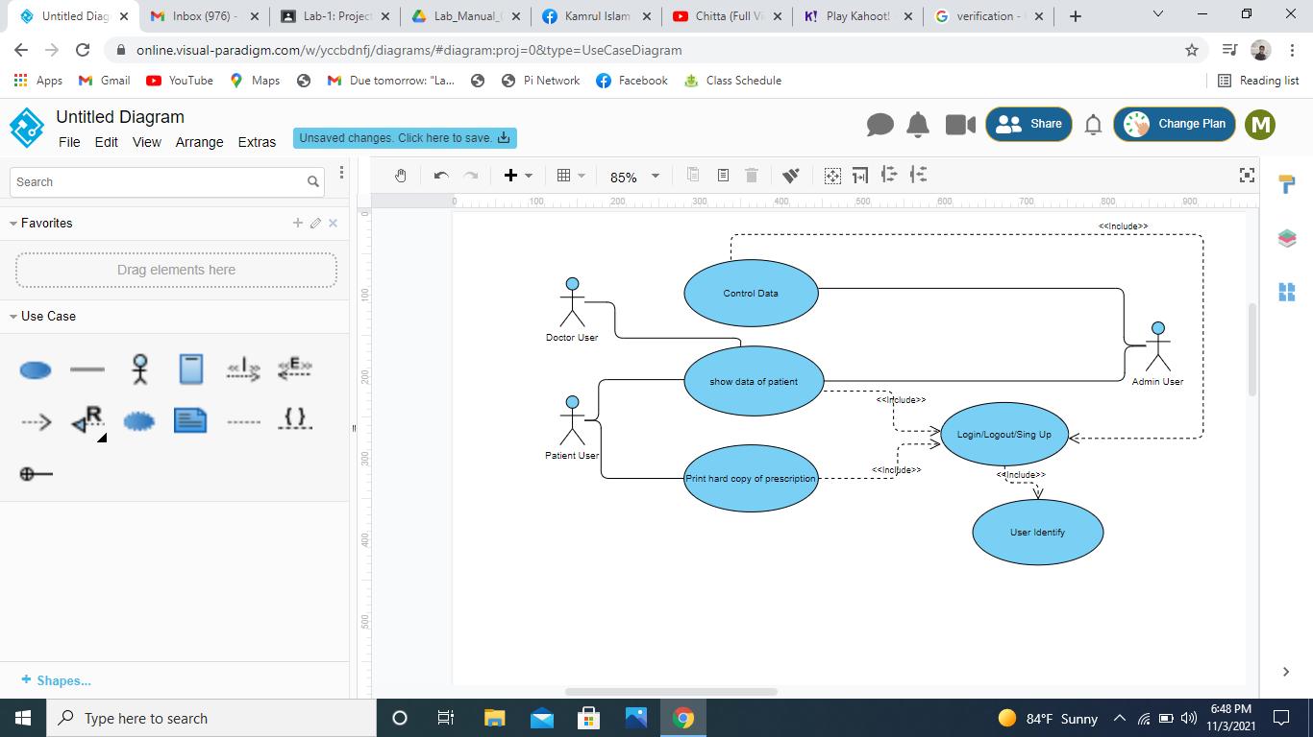

Figure 3: Use case diagram of Patient Support and Service System

**3.The Sequence and Communication Diagram of Patient Support and Service System is shown in Fig.4,5,6 and 7.**

